Task 5: Dynamic ZABBIX maps

A ZABBIX installation should be used to dynamically adapt and change ZABBIX maps with a world map as background to add and delete telescope positions.

Single tasks:

* Install Ubuntu Linux as Windows Wubi installation
* Install ZABBIX on Linux
* Understand ZABBIX
* Understand the ZABBIX API
* Write a program or script to create a new map and to add or delete a telescope position

The project has been built mainly based on the Zabbix as backend and Grafana to provide the front-end of the maps.

The concept is similar to NASA approach which is shown here (Page 14, <http://www.jive.eu/jumpingjive/lib/exe/fetch.php?media=wiki:jumping_jive_d8.4.pdf>)

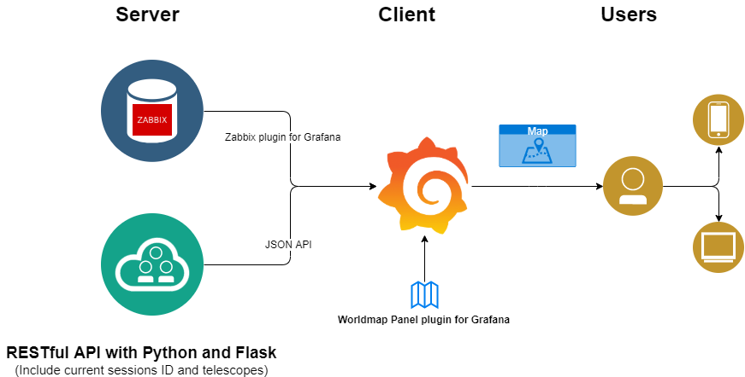

Figure : Workflow chart

**Docker**

To provide a better solution for deployment and easier for creation containers were used based on Docker to create different apps for each application. Then Docker-Compose is a used for defining and running multi-container Docker applications, Grafana, RESTful API Server, Zabbix, Database.

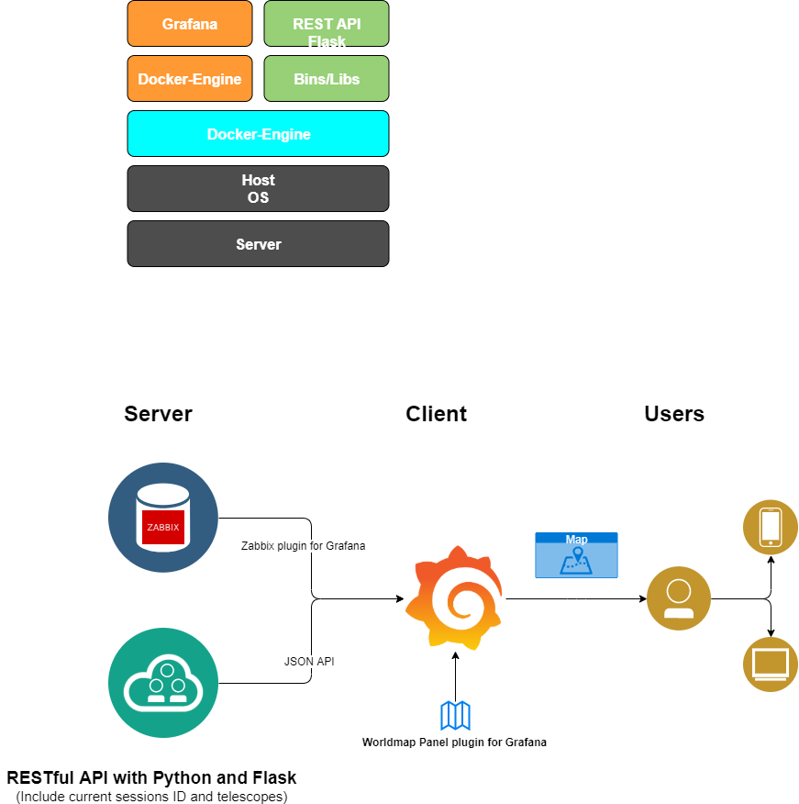

Figure : Docker Apps

**Tasks:**

1. Create Docker for each app

|  |  |  |  |
| --- | --- | --- | --- |
| Description | Progress | Timeline | Comments |
| Create Dockerfile for Zabbix, Grafana, and Flask on Linux, , mainly based on Zabbix | 100% | 07/2019-09/2019 | This is mainly to create multi-container for each app |

1. Install Plugin for maps and Zabbix

|  |  |  |  |
| --- | --- | --- | --- |
| Description | Progress | Timeline | Comments |
| Install needed Plugins on *Grafana* to connect to *Zabbix*, *Worldmap Panel* for for showing the map | 100% | 07/2019-08/2019 | This is mainly acquire the data from the server. |

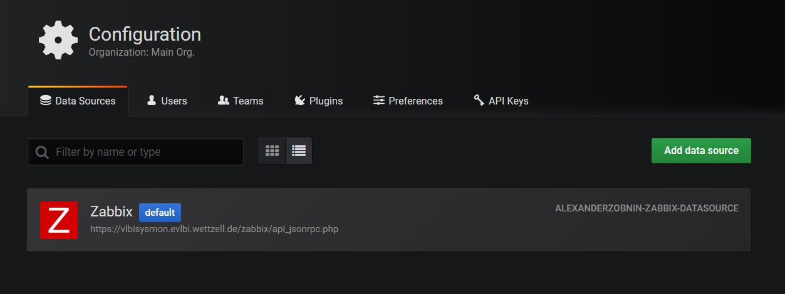

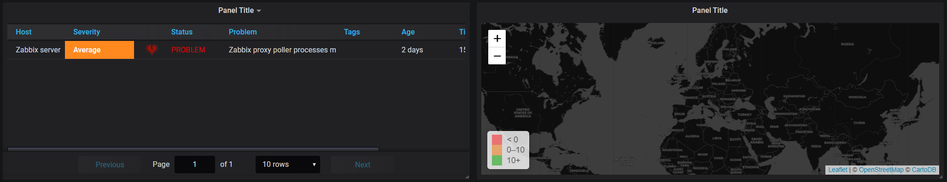



1. Create a script to Scrap all sessions information and current

|  |  |  |  |
| --- | --- | --- | --- |
| Description | Progress | Timeline | Comments |
| Create Python script for creating a dataframe from all the sessions and current session as well. | 100% | 08/2019-09/2019 | This is mainly acquiring the sessions from the server side. <https://ivscc.gsfc.nasa.gov/sessions/2019/> |

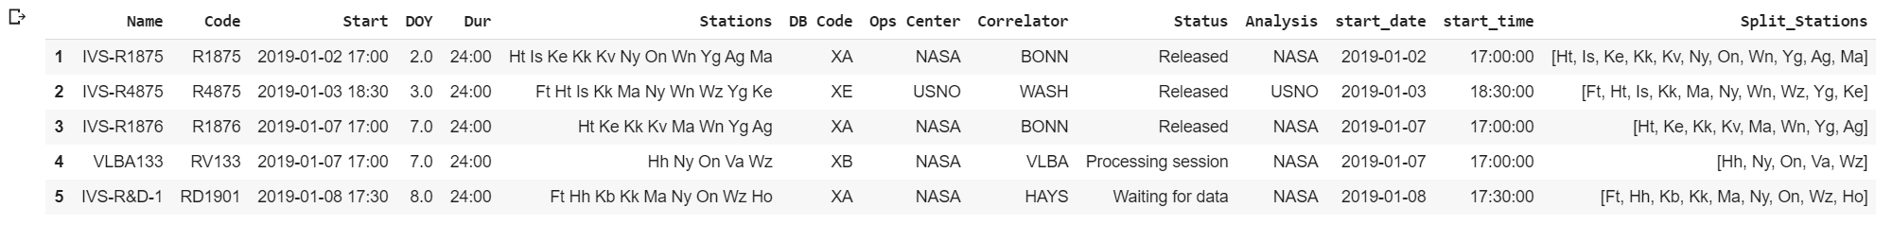

Current Session:



1. Create a database each telescope location, longitude, latitude

|  |  |  |  |
| --- | --- | --- | --- |
| Description | Progress | Timeline | Comments |
| Create database for each of the unique 40 telescopes location on the map, including longitude and latitude | 10% | 09/2019-?? | This task is currently blocked because I could not find website which provide information about the telescope location. |

This NASA website provide all Network Stations Code and Name but without any location information <https://ivscc.gsfc.nasa.gov/sessions/stations/>

*Where can the network station location be found?*

1. Script for parse current session as JSON

|  |  |  |  |
| --- | --- | --- | --- |
| Description | Progress | Timeline | Comments |
| Python script for each session as JSON | 100% | 08/2019-09/2019 | The JSON script is working correctly and providing the current and all sessions. |

{

"Name":"AOV039",

"Code":"AOV039",

"Start":"2019-09-17 17:30",

"DOY":260.0,

"Dur":"24:00",

"Stations":"Ho Is K1 Kg Sh Sy Vm Ww Yg Ke",

"DB Code":"XA",

"Ops Center":"GSI",

"Correlator":"GSI",

"Status":null,

"Analysis":"NASA",

"start_date":1568678400000,

"start_time":"17:30:00",

"Split_Stations”: ["Ho","Is","K1","Kg","Sh","Sy","Vm","Ww","Yg","Ke"]

}

1. Flask server to create a REST API

|  |  |  |  |
| --- | --- | --- | --- |
| Description | Progress | Timeline | Comments |
| Create docker and launch basic Flask server | 60% | 08/2019-09/2019 | Flask server as an API for POST and GET sessions. Still, it is a basic server. |

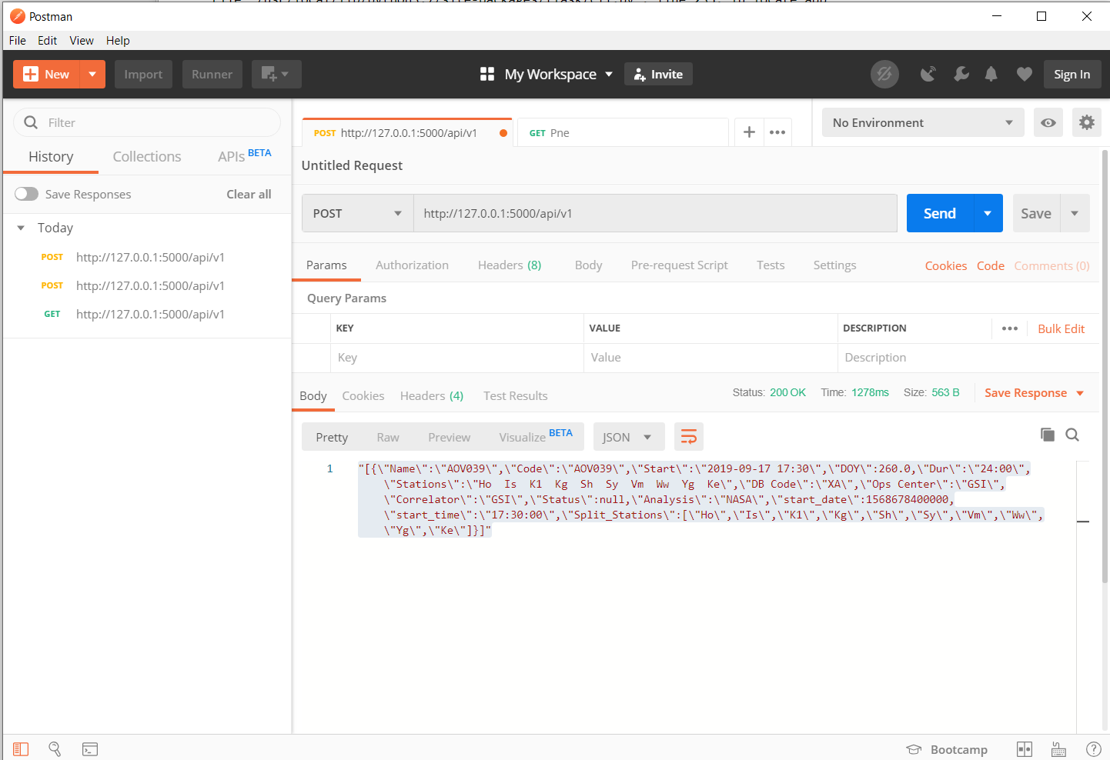

1. JSON server for all network stations location and code

|  |  |  |  |
| --- | --- | --- | --- |
| Description | Progress | Timeline | Comments |
| Create JSON server for station code and location | 10% | 09/2019-?? | This will be used as jsonp endpoint for worldmap location  -I need to learn more and JSON and POST GET for the API |

1. JSON server for current sessions information

|  |  |  |  |
| --- | --- | --- | --- |
| Description | Progress | Timeline | Comments |
| JSON server for providing current session ID and participating stations | 10% | 09/2019-?? | I need to learn and test more and JSON and POST GET for the API |

1. Modify Worldmap datasource from the Flask JSON Server and Zabbix

|  |  |  |  |
| --- | --- | --- | --- |
| Description | Progress | Timeline | Comments |
| Checking the main concept of Worldmap | 20% | 08/2019-?? | Worldmap requires the location of each satellite to be created in jsonp server, which include the location of each station. Input here from task 7 |

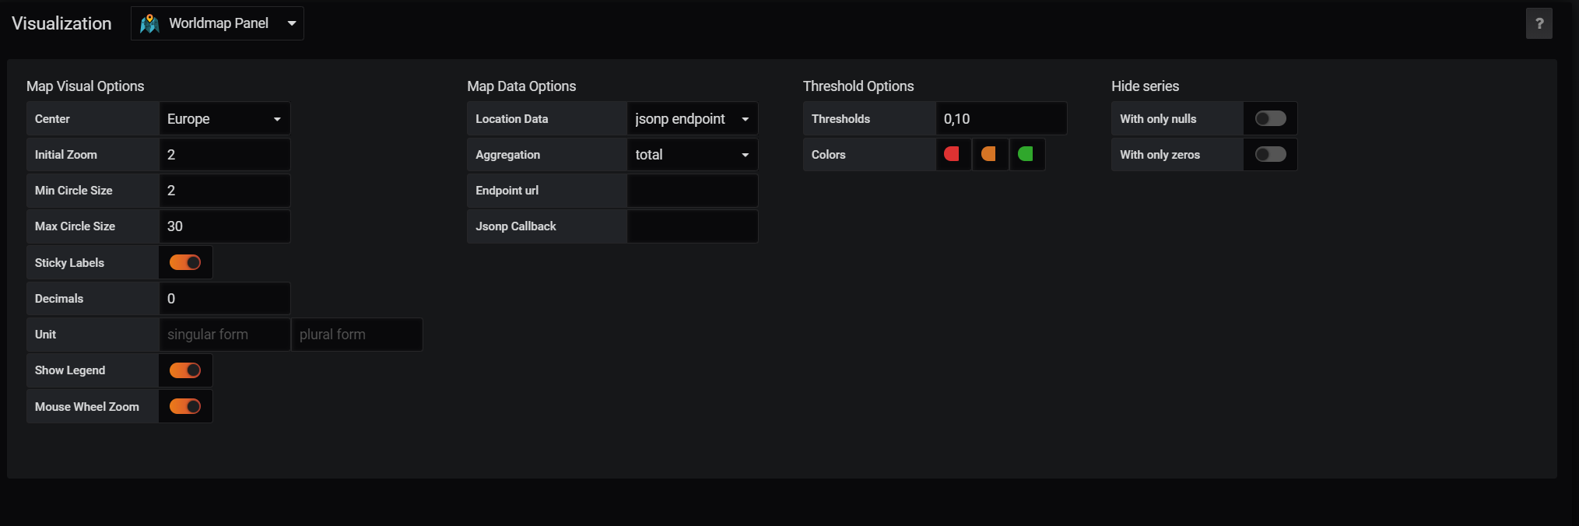

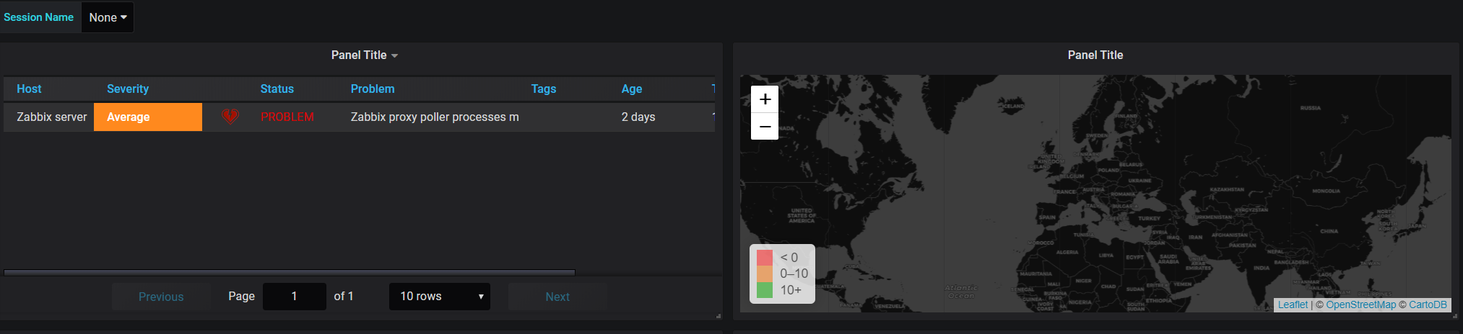

Current Running Servers:

Postgres Server  
<http://localhost:8080>

Zabbix  
<http://localhost:8090>

Grafana  
<http://localhost:3000>

Flask  
<http://localhost:5000>